**How to access one Moven module function into another module in Maven Project**

1. Export that module into Jars (Select Module then right click🡪 Export)

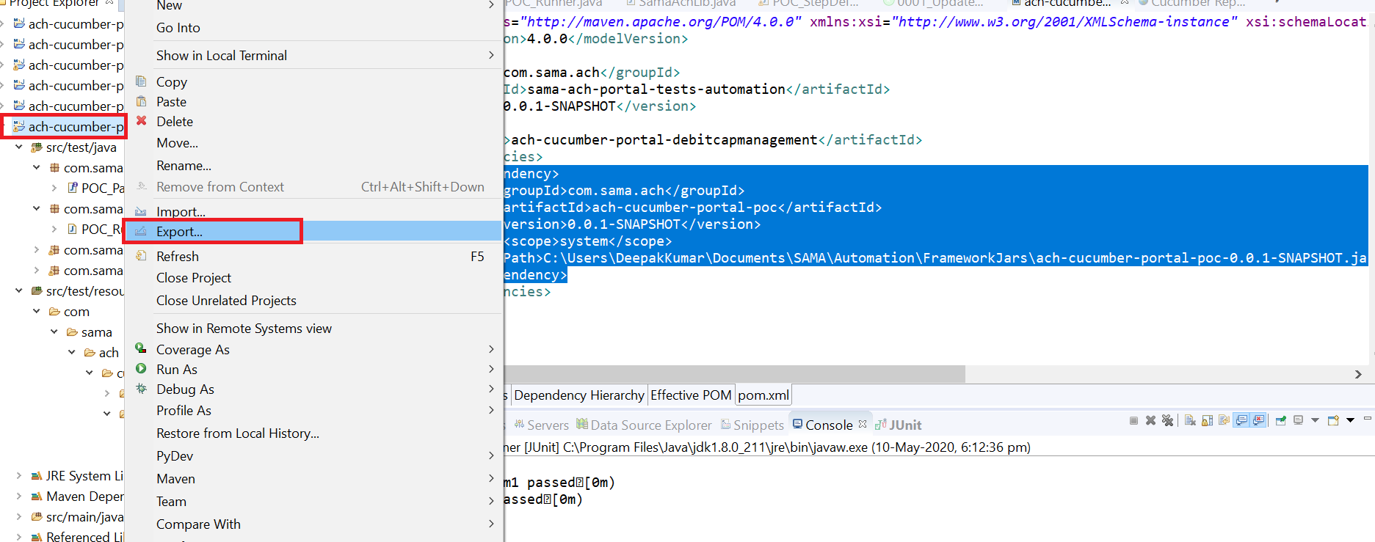

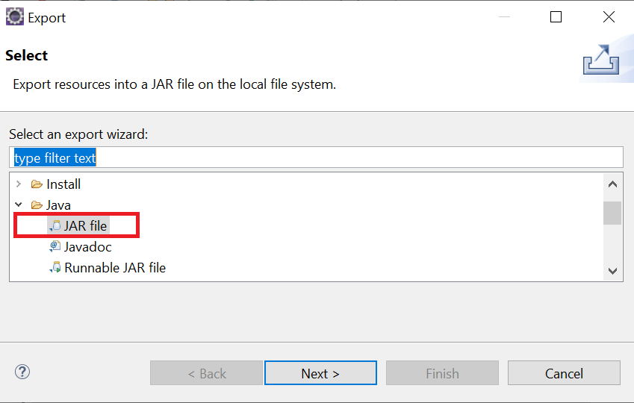

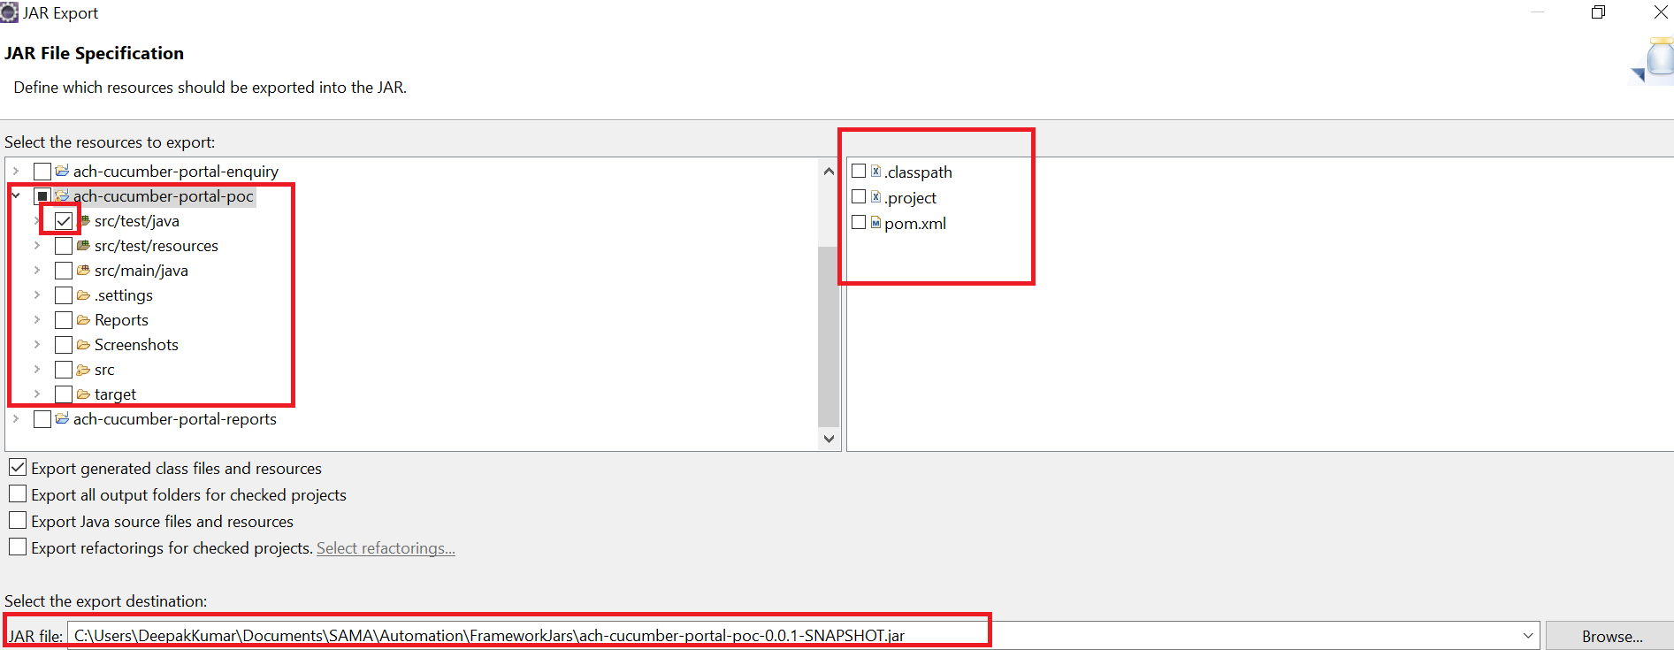

1. Save that exported jars in any location.

**Example**: C:\Users\DeepakKumar\Documents\SAMA\Automation\FrameworkJars\ach-cucumber-portal-poc-0.0.1-SNAPSHOT.jar

1. Add below code in any POM where you want to add this

<dependency>

<groupId>com.sama.ach</groupId>

<artifactId>ach-cucumber-portal-poc</artifactId>

<version>0.0.1-SNAPSHOT</version>

<scope>system</scope>

<systemPath>C:\Users\DeepakKumar\Documents\SAMA\Automation\FrameworkJars\ach-cucumber-portal-poc-0.0.1-SNAPSHOT.jar</systemPath>

</dependency>

1. hha